SurvivorSurvivor Helicopter!

Game Design Document

Open Game Developers

[Version: 0.0.0.1] | [Date: 04|08|2013]

Change Log

Version | Author | Changes
0.0.0.1 | El-Rico | Initial rough draft

Table of Contents

Overview 1
The Gist 1
The Gameplay 1
Common Elements 1
Singleplayer 1
Multiplayer 1
The Platforms 2
World 3
Characters 5
Survivor 5
Zombie 5
Helicopter 5
Director 6
Art Direction 7
List of Assets 9
Models 9
Player spawn points 9
Animations 9
Textures 9
Floor 9
City 9
Foley 9
Music 9
Glossary 12
References 14

Preface

This document shall describe the mechanics, lore, and narrative which will serve to further the tone of SurvivorSurvivor Helicopter! (hereafter referred to as SSH!)

Typographical notes
10-point Asul is for regular text
14-point Asul bold is for sub-sections
12-point Asul bold for sub-sub-sections
24-point Asul bold is for section titles
10-point Ubuntu bold is for suggestions or names which are still in flux or to be decided

Overview

The Gist
SSH! is a puzzle-based game where the objective is to direct survivors away from zombies, and into the safety of a helicopter, after they come running out of the building they were hiding in. In the singleplayer campaign, the player must place their directions and execute their plan with the goal of saving all survivors. Multiplayer mode has a different objective, where there are four competing members of <SomeOrg> who are trying to save as many survivors as they can for themselves, while other members are trying to sabotage the other players' survivor count.

The Gameplay
Common Elements
Place a limited amount of arrows on a 2D grid to direct your survivors
When a zombie collides with an arrow opposing it's direction, the arrow will decrease in influence and will be destroyed within a few of these hits

Singleplayer
Zombies destroy helicopters
Several levels of difficulty: Easy, Medium, Hard, Very Hard, and Insane
Linear path of progression, with the hardest difficulty level locked until all of the previous levels are completed
Each level has a high score
Scoring is based on time
Some levels will be time-sensitive when the execution phase begins

Multiplayer
Person with most survivors wins
Bonus +n survivor (counts as n survivors)
Either time-based or survivor-count-based, depending on what the host sets, though the player with the most survivors will win in the time-based mode
Zombies damage helicopters with a pre-set value by the multiplayer lead player (values to be determined).
Helicopters can take a certain amount of damage until they are destroyed.
If a helicopter is destroyed, the player will need to wait until a new helicopter flies in
Some survivors can repair helicopters and re-enforce them (depletes based on time?) (Can be toggled on or off)
Helicopters can carry a certain amount of survivors (up to infinite) which is set by the game's host
Buildings act as spawn locations for survivors, with from one to six on a level (depending on the level)
Various events occur, such as simultaneous spawning of zombies from all buildings, a dispersal of Bonus +n survivors from one building, switching the locations of the helicopters, repairing all helicopters, adding time to the clock, giving one player survivors from other players' helicopters (probably the weakest).

The Platforms
Linux - Launch
Windows - Launch
OUYA
Pandora

World

Locations
SSH! Takes place in several nondescript locations. A city, a forest, and on top of a few skyscrapers. There is a day/night cycle which can be fixed or toggled on or off with the speed determined by the host on the multiplayer version. The day/night cycle will be fixed for the singleplayer game.

City
Cities have a few buildings in the way of the survivors which will limit the paths they are able to take. Making the buildings look feasible while retaining the grid look will prove challenging.

Forest
Wide, open fields are where the survivors need to get to in order for the helicopters to pick them up.

Skyscrapers
The skyscraper levels are connected by rudimentary bridges, if directors are placed so that survivors could fall off the buildings, then the survivors will expire. On the Skyscrapers, the objective is to get the survivors to the stairwells and not let the zombies follow them.

Characters

Survivor
The survivor will have multiple permutations of cosmetic clothing which will serve no purpose other than to add variety to the survivors. There are survivors who have special properties (such as pregnant survivors and engineer survivors).
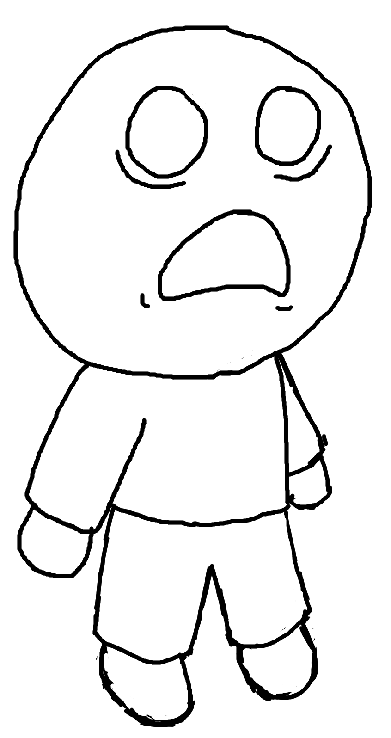Drawing 1: The base survivor

Zombie
Zombies advance on survivors at a slightly slower rate, so as to give the survivors a lead which can be lost due to mis-management. If a zombie happens across a helicopter, then it will take out a number of survivors (a random amount in a range of 10-30 (maybe more? Maybe less?)) and damage the helicopter. The attack on a helicopter is instantaneous as will the death of the zombie.

Helicopter
While not strictly a character, the helicopter does have some properties which make it useful to be described as such. Helicopters are able to hold either an infinite amount of survivors or a set amount by the host of the multiplayer session. Helicopters also have health and can be reinforced to protect survivors, the reinforced helicopter has another level of health, which, when depleted, will revert back to it's regular non-reinforced helicopter rules.
Director
Serving to direct the flow of zombies and survivors, directors have flashlights and signs to influence the path the survivors and zombies will take. If a zombie is approaching a director from the front, the director will become infected and turn into a zombie within a short amount of time, if a zombie approaches a director from any other direction, the director can deflect the zombie and send it in the intended direction (maybe make this a 50/50 chance of going on the path or on another path?).

Art Direction

The overall theme of SSH! is to have a cartoon world which is rendered in vibrant colours with purposeful and playful geometry. Characters are similar to those found in Dōbutsu no Mori, with large heads and small bodies, where the focus is on the face. In terms of colour choices, the vibrant, yet drab, look of Jet Set Radio would be ideal and would not be too loud.
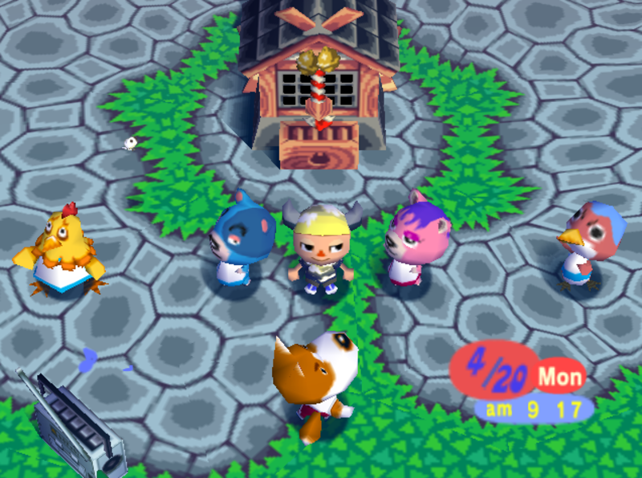Drawing 2: Dōbutsu no Mori. Image from [1].
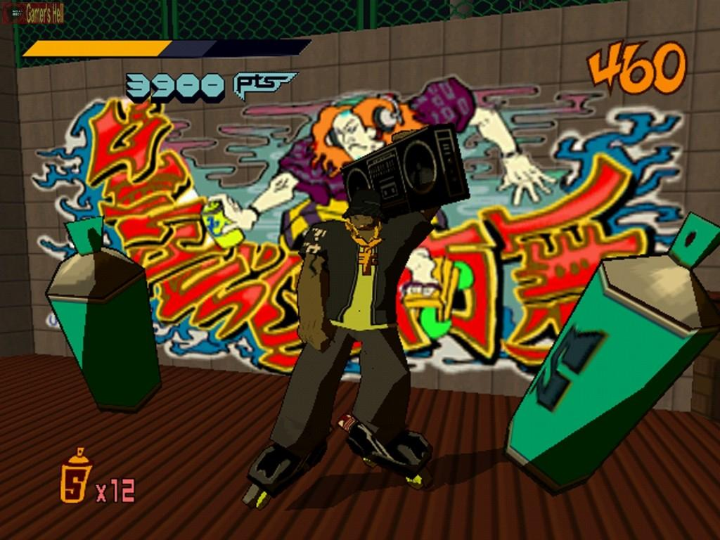Drawing 3: Jet Set Radio. Image from [2].

List of Assets

Models
Zombie
Survivor
Engineer Survivor
Helicopter
Reinforced Helicopter
Director
Flashlight
Arrow sign

Player spawn points
Forest – Cabin
City – Building
Skyscrapers – Improvised bridges

Animations
Survivor
Zombie
Director

Textures
Floor
City
Concrete
Debris
Building rooftops

Foley
Zombie groan (20 variations?)
Helicopter rotor
Survivors screaming (10 variations?)
Construction for the reinforced helicopter
Explosion for helicopter
Zombie giblets bounce
Zombie giblets detach
Zombie biting human
Deflection sound from shield for directors

Music
Title screen
Forest (lull, hectic, finale)
City (lull, hectic, finale)
Skyscrapers (lull, hectic, finale)

Release Schedule

Target Date: 31 October 2013 [31|10|2013]

August
05-11
12-18
19-25
26-01 September

September
02-08
09-15
16-22
23-29
30-06 October

October
07-13
14-20
21-27 -Polish
28-31 -Polish

Glossary

SSH! | SurvivorSurvivor Helicopter!

References

[1] | http://nsider2.com/forums/indexing/topic/443171-coolguy11s-review-of-dbutsu-no-mori-animal-forest
[2] | http://segabits.com/blog/2011/01/29/sega-sequel-saturdays-jet-set-radio

